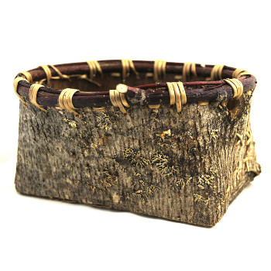
Mokok Basket 1 Day Workshop
Saturday October 25
______(address) Plainfield MA
10:00 am – 5:00 pm, bring your own lunch
$100
A Mokok is a Northeast woodland Native American style container made of bark, stitched with spruce roots. The bottom is rectangular while the top is round or oval. They were originally used to harvest and store food and accoutrements. Bark is to the Northeast woodland Tribes as Bison is to the Tribes of the Great Plains: the Lakota, Cheyenne, Osage etc. There is a season to harvesting bark that varies by species, weather, and growing situation.
In this class the sustainable harvesting of Bark, Roots and Red Willow will be discussed. You’ll learn to sew with spruce roots that you’ll prepare. If the roots are thick enough, you'll split them. An inner and outer rim is made by splitting a red willow stick that is bent gradually. Different stitching patterns will be shown. If you finish in time and so desire, you can embellish your basket with a collar and /or appliqué
Jennifer Lee has been enjoying making bark baskets for 40 years. Her interest began with the study of her Northeast woodland Native American ancestors. She teaches bark basket classes and educational programs extensively. The bark roots and branches are wild harvested by her family in the Northern Berkshire Mountains of Massachusetts. She’s received awards at the Mohegan Wigwam Festival, Saratoga Native American Festival, Mt Kearsage Indian Museum, Deerfield Craft Show, and North Carolina Basketmakers Association.
An apron is recommended. All tools will be provided, but if you’d like to bring your own, you’ll need:
- scissors
- utility knife
- needle nose plyers
- four-sided awl
- bowl for water

